Object-Oriented
Programming Lab

SPRING - 2024

LAB 04


FAST National University of Computer and Emerging Sciences

Learning Outcomes

In this lab you are expected to learn the following:

• Recursion
RECURSION

A recursive function is one that calls itself.

Example

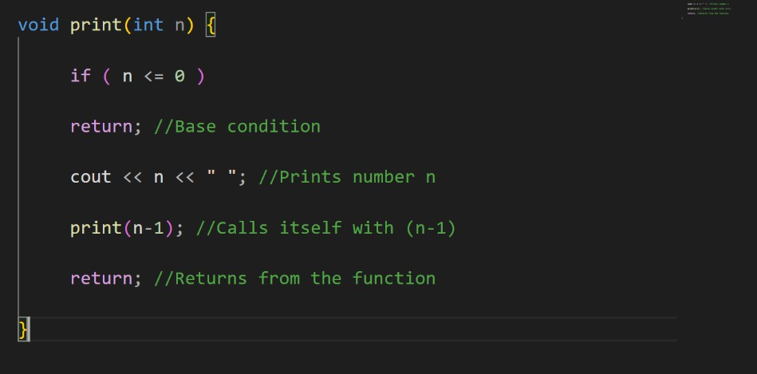

Output
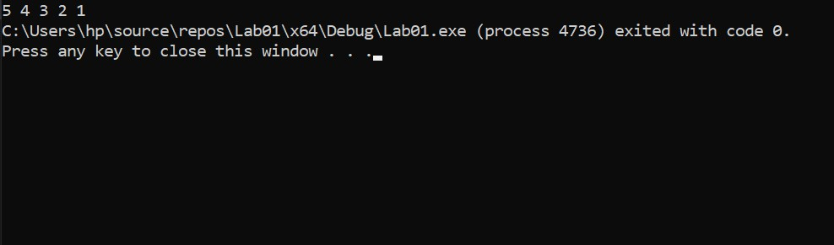

Problem 1.
Lab Tasks
Write a recursive function to get a count of a specific character in a given string. Example:
Input: const char* ptr=” wavelength”, char c=’e’ Output: 2 (as ‘e’ occurs two times in the “wavelength”)
Prototype of Function: int getCharCount(const char* ptr, char c) Problem 2.
Write a recursive function that takes a word as a parameter and returns a reverse word. Example
Input: hello
Output: olleh

Prototype of Function: string reverseWord(string word, int start, int end)
Problem 3.
The Fibonacci sequence is a series where the next term is the sum of the previous two terms. The first two terms of the Fibonacci sequence are 0 followed by 1. The Fibonacci sequence: 0, 1, 1, 2, 3, 5, 8, 13,
21. Write a function fab that takes a index of series as an argument and returns value in Fibonacci series.
Examples:
fibonacci (4) will return 3 fibonacci (6) will return 8
Prototype of Function: int fibonacci(int n)
Problem 4.
Write a recursive function to print the following pattern against a number entered by the user.

Input: 5
Output Pattern

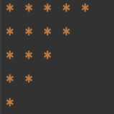

Problem 5.
Write a C++ recursive function to print following pattern. Prototype of Function: void diamond_pattern(int num)

For n=13 , n=11 , n=9 , n=7

